Multi-Step Tumorigenesis
Spring 2021

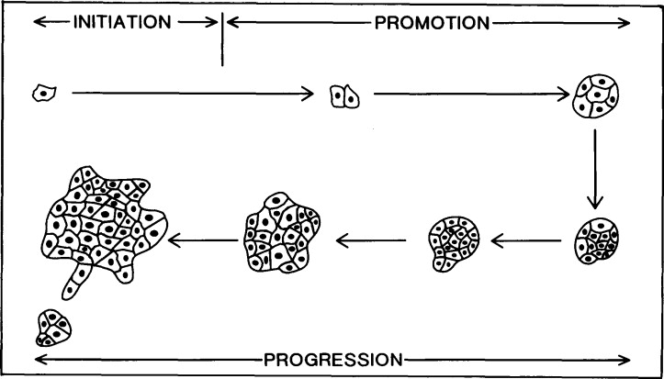
From “Mechanisms for the initiation and promotion of carcinogenesis: a review and a new concept.” by Scott, R E et al.

Topics
Introduction 2
From an Epidemiological Lens 3
Histopathology 5
Cancer is a Genetic Disease 5
Genetic Mutations and Epigenetic Alterations 6
Hallmarks of Cancer 7
Multi-Step Tumorigenesis: Initiation, Promotion, and Progression 9
Initiation 10
Initiators and Promoters 11
Promotion 12
Progression 12
Tumor Progression is Not A Linear Path 12
Tumor Microenvironment 13
Angiogenesis 14
Inflammation and Cancer 15
Malignancy 15
Conclusion 17

Introduction
There are millions of cells within our bodies that all go through a life cycle. In time, these cells will reproduce and replenish themselves as old ones die or become defective, usually without issue. Yet this is not guaranteed every single time. Rather than eliminating old cells or cells that have sustained damage to their genes. The flawed cells may start dividing rapidly and pass along abnormal copies of themselves. This eventually will form a mass or tumor that can be benign or malignant.
In this lecture, I will summarize the topic of multi-step tumorigenesis and how it is related to other parts of our course. Multi-step tumorigenesis is a model or hypothesis of how normal cells undergo genetic mutations and epigenetic alterations which will progress into the formation of a tumor. The steps of tumorigenesis include initiation, promotion, and progression - which will be discussed in detail. Additionally, I will discuss the tumor microenvironment - the environment in which a tumor is able to grow as well as the hallmarks of cancer. Understanding each of these topics can help assess treatments for cancer. Multi-step tumorigenesis, which was formed by piece-by-piece discoveries.
The current multistep model of tumorigenesis proves to be more complex than what was previously understood in clonal evolution. Multi-step tumorigenesis is divided into three stages: initiation, promotion, and progression. It may result from the action of one or a combination of chemical, physical, biological, or genetic insults.
In most cases cancer is a disease of aging. The incidence rates of various cancers are strongly related to lifestyle and environmental factors. A cancerous growth has a number of predictable properties and growth characteristics which includes the ability to grow in an uncontrolled manner, invade surrounding tissues, and metastasize. Most cancers arise from a single clone of cells, whose precursor may have been altered by insult with a carcinogen.¹⁰
There is frequently a long latent period, in some cases 20 years or more, between the initiating insult and the appearance of a clinically detectable tumor. During this time, cellular proliferation must occur, but it may originally be limited by host defenses or lack of access to the host’s blood supply. During the process of tumor progression, however, escape from the host’s defense mechanisms and vascularization of the growing tumor ultimately occurs.¹⁰
The genetic instability of cancer cells leads to the emergence of more aggressive growing tumors which are characterized by the appearance of poorly differentiated cells with certain properties of a more embryonic phenotype. During tumor progression, considerable biochemical heterogeneity becomes manifest in the growing tumor and its metastases, even though all the neoplastic cells may have arisen originally from a single deranged cell.¹⁰

Classification of Cancers
Name | Origin | Examples
Carcinoma | Epithelial | Breast, lung, colon, and prostate
Sarcoma | Connective tissue; mesenchymal | Osteosarcoma (bone); Chondrosarcoma (cartilage)
Lymphoma  Leukemia | Hematopoietic cells | Hodgkin’s lymphoma
-oma = means swelling or tumor

From an Epidemiological Lens
Cancer can develop at any age and in any tissue in the body. The clinical presentation of these cells is variable, however all cancers share a common principle - a gradual acquisition of errors in genes. In the big picture, the development of cancer is a function of genetic inheritance, environment, diet, and age. Epidemiologic studies have shown that age is a large factor in the incidence of cancer. In fact, the risk of dying from colon cancer is almost 1000 times greater in a 70 year old man than a 10 year boy.¹³
Steps in multi-step tumor progression proceed faster at later stages because cells in the later growth have acquired multiple oncogenic mutations, have learned to proliferate faster, decrease the timing of clonal expansion, and genome cells are more likely to become mutable. Epidemiologists have found that there is a strong age dependence across all cancers.
Tumorigenesis is a multi-step process in which a sequence of genetic mutation and epigenetic alteration events are required for a tumor to appear. The formation of a tumor is a complex process that usually proceeds over a period of decades. Normal cells evolve into cells with increasingly neoplastic phenotypes through a process termed as tumor progression. This process takes place at myriad sites throughout the normal human body, advancing further and further as we get older. Rarely does it proceed far enough at any single site to make us aware of its end product, a tumor mass.¹³
As we grow older, virtually all of us will accumulate cells in many locations throughout our bodies that have completed some, but not all the steps of tumor progression. Just by examining the frequencies of mesothelioma in humans, epidemiologists have found that the formation of tumors requires an extended period of repeated exposure to carcinogens. The time period of these exposures is what determines the timing of the onset of cancer. In these cases, tumors are created by the actions of exogenous carcinogens rather than occurring spontaneously within the body. These carcinogens increase the rate of tumor progression.
Tumor progression is driven by a sequence of randomly occurring mutations and epigenetic alterations of DNA that affect the genes controlling cell proliferation, survival, and other traits associated with the malignant cell phenotype. The complexity of this process reflects the work of evolution. The cell cycle and other cellular mechanisms create a series of barriers between normal cells and their highly neoplastic derivatives. Since most of us will not live long enough for the full schedule of requisite events to be completed we will never realize that any of these tumor progressions had been initiated in our bodies.¹³
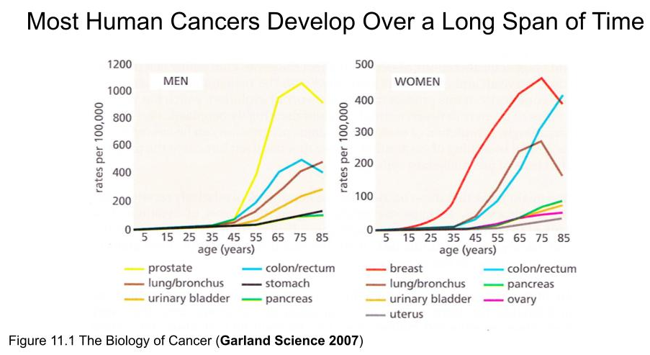
From The Biology of Cancer (2014) by Robert A. Weinberg
The process of tumorigenesis is an interplay between genetics and the environment. Most cancers arise after genes are altered by carcinogens or by errors in the copying and repair of genes. Even if the genetic damage occurs only in one somatic cell, division of this cell will transmit the damage to the daughter cells, giving rise to a clone of altered cells. The causes of cancer can be both external and internal. The presence of environmental chemicals and radiation which are external or immune system defects, genetic predisposition which are internal; all play a role in initiating and promoting multistep tumorigenesis. Being consistently exposed to causative factors over long periods of time will eventually act together to initiate, by the initial genetic insult, and promote, by stimulation of growth of initiated cells, carcinogenesis.
Agents Classified as Human Carcinogens by IARC
Acetylaldehyde  Aflatoxin  Arsenic  Asbestos  Benzene  Benzo[a]pyrene  1,3 Butadiene  Cadmium  Chromium VI | Coal tar  Dioxins  Estrogens  Ethanol  Helicobacter pylori  Ionizing radiation  Formaldehyde  Radon  Vinyl chloride
From Carcinogenesis: Mechanisms and Manifestations. Waltham, MA, Haschek and Rousseaux’s Handbook of Toxicologic Pathology Vol 1 (2013) :107-146. by Malarkey, DE; Hoenerhoff, M; Maronpot, RR.

Histopathology
The cells of the human body are very small and not visible to the naked eye - making it difficult to comprehend the total number of cells in the human body. The current accurate estimate is 30 trillion cells in the body. As cells age, they are continuously replaced within the average human lifespan. All of these cells are derived from preexisting cells which are tightly regulated by the cell cycle and control mechanisms. Loss of cell cycle control leads to uninhibited cell division and cancer development. The theory that human tumor development is a multi-step process has been histologically documented most clearly in the epithelia of the intestine. In fact, the altered histopathology of premalignant and malignant growths is largely a reflection of changes that have occurred in a group of cells forming each of these masses. In the case of carcinomas, the progressive alteration of epithelial cells is accepted to drive the process of tumor progression and the associated changes in histopathology. The other cell types in these tumor masses, specifically those in the stroma, are normal cells that have been recruited to the tumor mass and recruited by abnormal epithelial cells to help in the process of tumor formation. This figure below shows a normal duct and notice how the cells are organized, whereas the cells in luminal carcinoma and basal carcinoma are disorganized.¹³
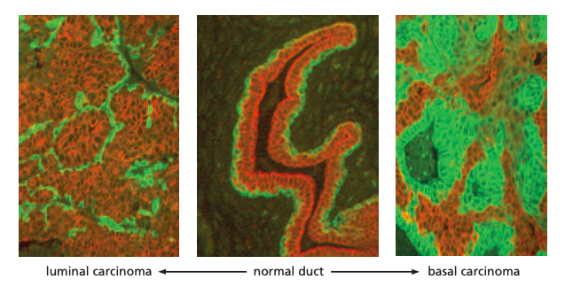
Figure 11.13 The Biology of Cancer (Garland Science 2007)
From The Biology of Cancer (2014) by Robert A. Weinberg

Cancer is a Genetic Disease
The process of tumorigenesis involves the alterations of four categories of cancer genes where oncogenes are activated, tumor suppressors are inactivated, the evasion of apoptosis genes, and defective DNA repair genes. Loss of cellular regulation can give rise to most cases of cancer due to genetic damage. During multi-step tumorigenesis, each neoplasm will accumulate at least 80 genetic alterations in its cancer genes, many of which will be ‘driver’ mutations causing uncontrolled growth.
Mutations in two broad classes of genes have been implicated in the onset of cancer: proto-oncogenes and tumor suppressor genes. These proto-oncogenes are activated by mutations to become oncogenes, which will cause the gene to be excessively active in growth promotion, as a result of either increased gene expression or production of a hyperactive product. Tumor- suppressor genes normally restrain growth, so damage to them allows uncontrolled growth. Many of the genes in both classes encode proteins that help regulate cell birth or cell death by apoptosis; others encode proteins that participate in repairing damaged DNA.⁸
Cancer commonly results from mutations that arise during a lifetime’s exposure to carcinogens, which include certain chemicals and ultraviolet radiation. Cancer-causing mutations occur mostly in somatic cells, not in the germ-line cells. These somatic cell mutations are not passed on to the next generation. Moreover, certain inherited mutations are able to be carried in the germ line, increasing the probability that cancer will occur at some time. Somatic mutations can combine with inherited mutations to cause cancer. Carcinogens can activate cellular oncogenes (proto-oncogenes) by a variety of mechanisms including base substitution (point) mutations, chromosomal translocations, and gene amplification.¹

Looking at Mechanisms of Action: Examples of Cancer Genes
Oncogenes | Tumor Suppressors
Growth factors (Sis)  Growth factor receptors (EGFR, PDGFR, HER2/neu)  Signal transduction (ras, abl, b-catenin)  Cell cycle regulators (cyclin D, Cdk4) Transcription factors (myc) | Cell surface (TGF-bR)  Cytoskeleton (NF2)  Cytosol (APC/b-catenin, PTEN, Smad 2) Transcription factors (Rb1, p53, Brca1)  Cell cycle regulators  Apoptosis evasion (p53, bcl-2, bcl-x, bax) Defective DNA repair (XP, HNPCC, MLH1, ATM, Brca1, Brca2)
From Carcinogenesis: Mechanisms and Manifestations by David E. Malarkey, Mark Hoenerhoff, Robert R. Maronpot

Genetic Mutations and Epigenetic Alterations
Multi-step tumorigenesis is considered to be the accumulation of genetic mutations within cells that affect both the tumor suppressor genes and oncogenes. Moreover, epigenetics refers to reversible, heritable changes in gene expression that will occur without mutation. These epigenetic alterations include post-translational modifications of histones and DNA methylation, which affect gene expression.
In the cell cycle, checkpoints allow for DNA repair before further progression into the cycle. The components of checkpoint control act as “brakes” the cycle when overcome by stress or damage. Overriding the cell cycle checkpoints with agents such as methylxanthine analogs or pentoxifylline increases the cytotoxicity of DNA-damaging agents. The importance of DNA damage in triggering a cell cycle shutdown is obvious. Replication of a damaged template would result in irreversible chromosomal aberrations and a high mutation rate. Two major checkpoints following DNA damage have been established at the middle to end of G1 (prior to DNA replication) and G2 (prior to chromosome segregation).⁸
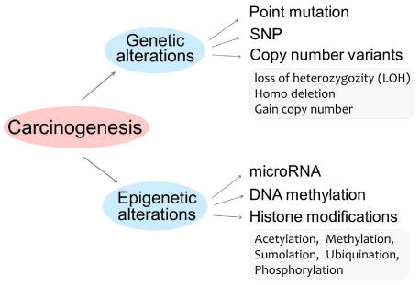
From Genetics and Epigenetics in Tumorigenesis: Acting Separately or Linked? By Zhu X, Wetta H

Hallmarks of Cancer
Cancer researchers Robert Weinberg and Douglas Hanahan first published the Hallmarks of Cancer in 2000. Which has been the most cited cell article of all time in the journal Cell (Cancer Network 2011). In 2000, the hallmarks of cancer included six principles: sustaining proliferative signaling, evading growth suppressors, activating invasion and metastasis, enabling replicative immortality, inducing angiogenesis, and resisting cell death. More than ten years later, in 2011, the Hallmarks of Cancer was updated by Hanahan and Weinberg in which they added enabling characteristics and emerging hallmarks. These include deregulating cellular energetics, avoiding immune destruction, tumor-promoting inflammation and genome instability and mutation. The hallmarks of carcinogenesis include genetic alterations involved in⁵:

- Sustaining proliferative signaling
- Evading growth suppressors
- Resisting cell death
- Enabling replicative immortality
- Inducing angiogenesis
- Activating invasion and metastasis
- Reprogramming energy metabolism
- Evading immune destruction

Sustaining proliferative signaling
The most fundamental trait of cancer cells involves their ability to sustain chronic proliferation. In normal tissues, there is a tight control in the production and release of growth promoting signals that instruct entry into and progression through the cell growth and division cycle. This process ensures a homeostasis of cell number, which will maintain the normal tissue architecture and function. By deregulating these signals, cancer cells become the masters of their own destinies. The enabling signals are conveyed in large part by growth factors that bind cell-surface receptors, which contain intracellular tyrosine kinase domains. These proceed to emit signals via branched intracellular signaling pathways that regulate progression through the cell cycle as well as cell growth. These signals also influence other cell-biological properties such as cell survival and energy metabolism.⁵

Evading growth suppressors
Cancer cells can evade growth suppressors, which are powerful programs that negatively regulate cell proliferation such as tumor suppressor genes. Examples of tumor suppressors that suppress proliferation—TP53 and RB—have preeminent importance in regulating cell proliferation.⁵

Activating invasion and metastasis
The multistep process of invasion and metastasis has been schematized as a sequence of discrete steps, often termed the invasion-metastasis cascade. This depiction envisions a succession of cell-biologic changes, beginning with local invasion, then intravasation by cancer cells into nearby blood and lymphatic vessels, transit of cancer cells through the lymphatic and hematogenous systems, followed by escape of cancer cells from the lumina of such vessels into the parenchyma of distant tissues (extravasation), the formation of small nodules of cancer cells (micrometastases), and finally the growth of micrometastatic lesions into macroscopic tumors, this last step being termed “colonization.”⁵
Inducing angiogenesis
Tumors require sustenance in the form of nutrients and oxygen as well as an ability to evacuate metabolic wastes and carbon dioxide. The tumor-associated neovasculature, generated by the process of angiogenesis, addresses these needs. During embryogenesis, the development of the vasculature involves the birth of new endothelial cells and their assembly into tubes (vasculogenesis) in addition to the sprouting (angiogenesis) of new vessels from existing ones. Following this morphogenesis, the normal vasculature becomes largely quiescent. During tumor progression, an angiogenic switch is almost always activated and remains on which causes normally quiescent vasculature to continually sprout new vessels that help sustain expanding neoplastic growths.⁵

Deregulating cellular energetics
The majority of cell injury is brought about by hypoxia, which is a decrease in the supply of oxygen, and anoxia, which is a complete block in the oxygen supply. Hypoxia and anoxia occur when there is an inadequate oxygen supply (i.e. low concentration of oxygen in air at high altitudes, drowning, or lung disease), a failure in oxygen transport in blood (anemia), a disruption in blood flow (ischemia, caused by heart failure), blood vessel obstruction (thrombosis or embolism), disruption in blood supply (rupture of an aneurysm) or a consequence of inhibition of cellular respiration (cyanide poisoning).⁵

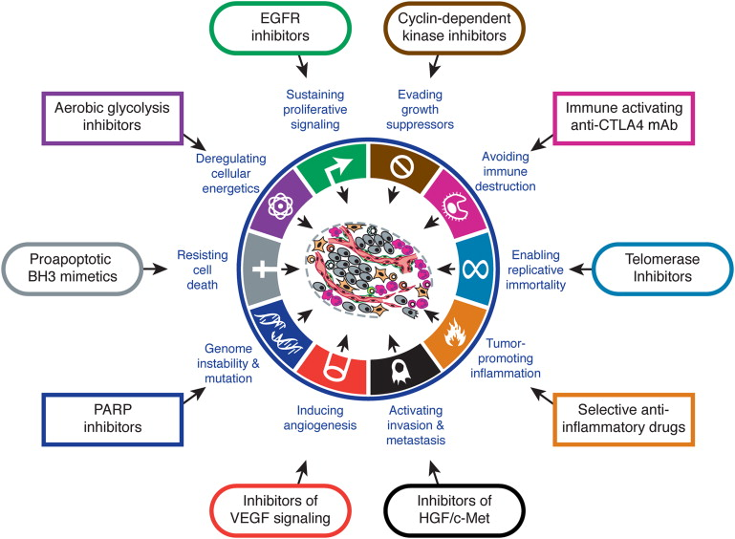
From Hallmarks of Cancer by Hanahan and Weinberg

Multi-Step Tumorigenesis:

Initiation, Promotion, and Progression
Long term exposure to carcinogens can lead to the development of cancer. The later steps in multi-step tumor progression most likely require less time to complete than earlier steps because cells in later growth have acquired multiple oncogenic mutations, have learned to proliferate faster, decreased the time of each clonal expansion, and genomes of cells have become more mutable. Tumor growths can arise in any part of our body and the body has a system of checkpoints in each of our organs that keeps it in homeostasis. When this equilibrium mechanism is broken, an uncontrolled growth in our body can develop. These growths can be benign, but some may become malignant, or cancerous. Tumors can grow in solid tissues such as organs, joints, or bones. In some cases, a tumor can be felt and other times are only detectable with imaging tests such as an MRI, CT scan, PET scan, endoscopy, or ultrasound. A biopsy is often needed so that it can be evaluated under a microscope to determine if it is a benign, precancerous, or malignant tumor.
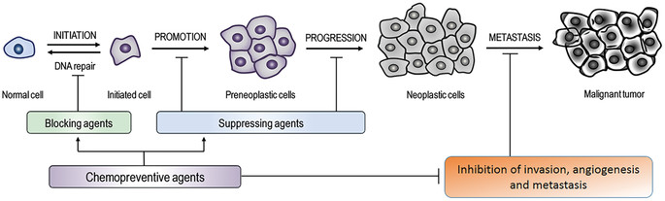
From Resveratrol nanoformulation for cancer prevention and therapy

Initiation
Carcinogens can induce damage in tumor suppressors or oncogenes in ways which contribute to the transformation of normal cells into tumor cells, known as tumor initiation. Additionally, chemical carcinogens are also capable of promoting the outgrowth of those transformed cell clones, causing the generation of visible tumor cell masses known as tumor promotion.⁷
An initiator is an agent that triggers the first step in multi-step tumorigenesis. Likewise, the promoter is an agent that furthers the progression of multi-step tumorigenesis by non-genetic mechanisms, mainly those involving inflammation and mitogenesis. Promoting agents may cause gene repression and derepression in cells. They include agents such as drugs, plant products, and hormones, which do not directly interact with host cellular DNA but will influence expression of genetic information.⁷

Initiators and Promoters
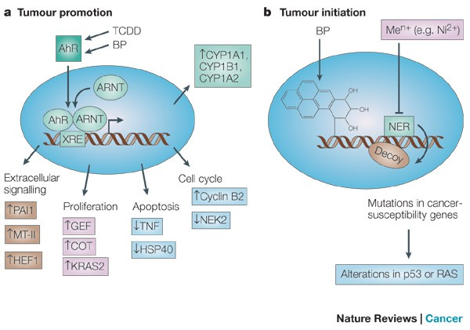
Tumor promotion vs Tumor Initiation

Characteristics of Initiators and Promoters of Neoplasia
Initiators | Promoters
- Irreversible  - Additive  - Cannot identify cells  - “Pure” initiation does not result in neoplasia unless promoter is subsequently applied  - Number of initiated cells dependent on dose  - No measurable threshold dose  - Agents are considered carcinogens  - Must be administered before the promoter  - Only one exposure may suffice  - Electrophile production and covalent binding to DNA  - Agents usually mutagenic | - Reversible  - Non-additive  - Agents not capable of initiation  - Modulated by diet, hormonal, environmental, and related factors  - Measurable threshold dose  - Agents not considered carcinogens but co-carcinogens  - Must be administered after the initiator  - Prolonged exposure is usually required  - No electrophile production and no covalent binding to DNA  - Agents usually not mutagenic
From Handbook of Toxicologic Pathology, 2nd Ed. W. M Haschek, C. G. Rousseaux and M. A. Wallig, eds. (2002) Academic Press, Vol. I, Table V, p. 94

Promotion
Promotion is considered that portion of the multistep tumorigenic process where specific agents, known as promoters. These will enhance the development of neoplasms from a background of initiated cells. Promotion of carcinogenesis in an initiated stem cell will acquire the ability to override all growth-regulatory processes. Cancer derived by such a mechanism would be expected to show a well-differentiated, slowly growing phenotype. The promotion of multi-step tumorigenesis results when such initiated stem cells develop irreversible autoregulatory control mechanisms that cause abnormal cellular proliferation in differentiation-defective stem cells.⁸

Progression
The development of a cancer requires a gradual accumulation of mutations in a number of different genes which explains the phenomenon of tumor progression. The process of progression involves the initiated cell to expand clonally into a detectable cell mass that can be either benign or preneoplastic.⁸
An initial mild disorder of cells will evolve gradually into a full-blown cancer. An example of this can be understood from chronic myelogenous leukemia. This disorder is characterized by a nonlethal overproduction of white blood cells and continues in this form for several years before changing into a much more rapidly progressing illness that usually ends in death within a few months. In the early chronic phase, the leukemic cells are distinguished mainly by the chromosomal translocation. In the subsequent acute phase, cells that show not only the translocation but also several other chromosomal abnormalities which overwhelm the hematopoietic system. It appears that cells from the initial mutant clone have undergone further mutations that make them proliferate even more vigorously and outnumber both the normal blood cells and their ancestors with the primary chromosomal translocation.⁸

Tumor Progression is Not A Linear Path
The general understanding of clonal succession proposed until now suggests that all of the cells within a tumor mass that participate in a particular clonal expansion are genetically identical to one another and that tumor formation occurs as a consequence of a linear series of these clonal successions. Based on this, if we were to examine the cells within a premalignant or malignant cell mass, we would almost always find that a single, genetically homogeneous clone of cells dominates in this mass, since it would have outgrown and largely displaced the preceding cell clone from which it arose.¹
The actual course of tumor progression is complex. One factor that we must take into account is that as tumor progression advances, tumor genomes often become increasingly unstable. The rate at which mutations are acquired during each cell generation becomes exponential. As a consequence, rather than looking like a linear series of clonal successions, actual tumor progression in many tumor masses is likely to resemble the highly branched scheme, in which a number of genetically distinct subclones of cells coexist within a single tumor mass. The dynamic nature of their expansion and subsequent replacement is represented below¹:
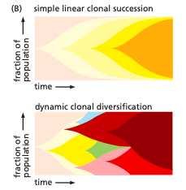
Genetic diversification of cells within tumor masses can be obtained by tracking the state of individual genes of interest within various cells of a primary tumor. For example, in a human pancreatic carcinoma, detailed genome sequence analysis of different sectors of the tumor revealed genetically distinct sub- clones, each of which was estimated to comprise at least 100 million cells. The localization of individual subclones and associated cells within a tumor is itself unclear. Computer-based modeling can give insight on how such subclones arise and are distinguished from one another by heritable differences in DNA sequence or CpG methylation. Analysis of individual carcinoma cells within a tumor may reveal this is more complex than imingaine, where the cells of various subclones in fact become intermingled.¹

Tumor Microenvironment
The cancerous cells in a tumor carry dangerous mutations and have an abnormal structure in comparison to other cells in a tumor. The development of a tumor relies on a two-way communication between the tumor cells and the tumor stroma. This development is similar to how the normal development of epithelial organs relies on communication between epithelial cells and mesenchymal cells.¹
The stroma provides a framework for the tumor. It is composed of normal connective tissue containing fibroblasts, inflammatory white blood cells, and endothelial cells that form blood and lymphatic vessels with nearby pericytes and smooth muscle cells. As a carcinoma progresses, the cancer cells induce changes within the stroma by secreting signal proteins that alter the behavior of the stromal cells, as well as proteolytic enzymes that modify the extracellular matrix. The stromal cells in turn act back on the tumor cells, secreting signal proteins that stimulate cancer cell growth and division as well as proteases that further remodel the extracellular matrix. As such, the tumor and stroma will evolve together, invade, and the tumor will become dependent on the stromal cells.¹

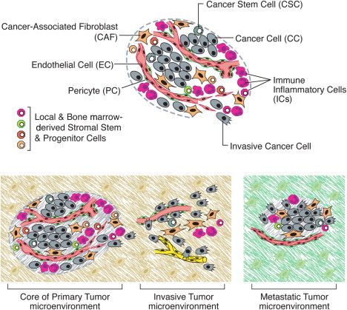
From Hallmarks of Cancer: The Next Generation by Hanahan and Weinberg

Angiogenesis
In angiogenesis new blood vessels form which allow the delivery of oxygen and nutrients to the body’s tissues. Angiogenesis has an important role in tumor formation. In early phases of angiogenesis, the tumor resides in a dormant state, here the rate of cell death counterbalances cell proliferation. Part of this is due to hypoxia and the insufficient available nutrients in the microenvironment. Then the tumor activates an angiogenic switch, which is irreversible, and begins to recruit new capillaries which will bring in oxygen and nutrients to both angiogenic cells and surrounding non-angiogenesis cells. This leads to an exponential tumor growth.
During tumorigenesis, the balance between pro-angiogenic and anti-angiogenic molecules and autocrine and paracrine growth factor stimulation is lost. The main mechanism, known as endothelial sprouting, depends on vascular endothelial growth factor upregulation and the development of functional interactions between endothelial cells, pericytes, stromal cells, and the associated extracellular membrane.²
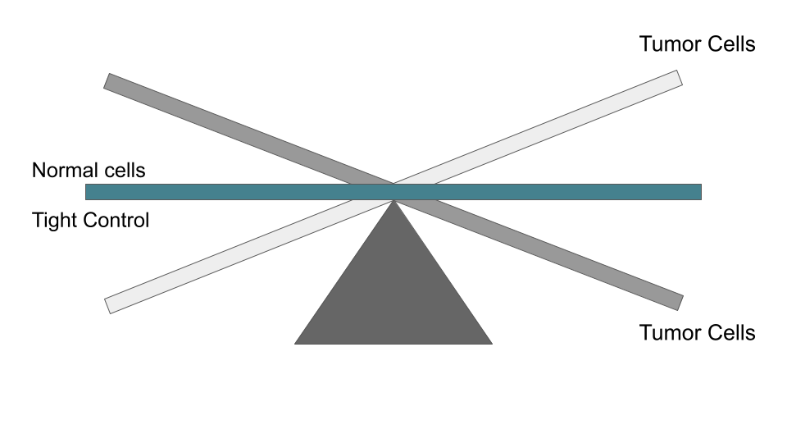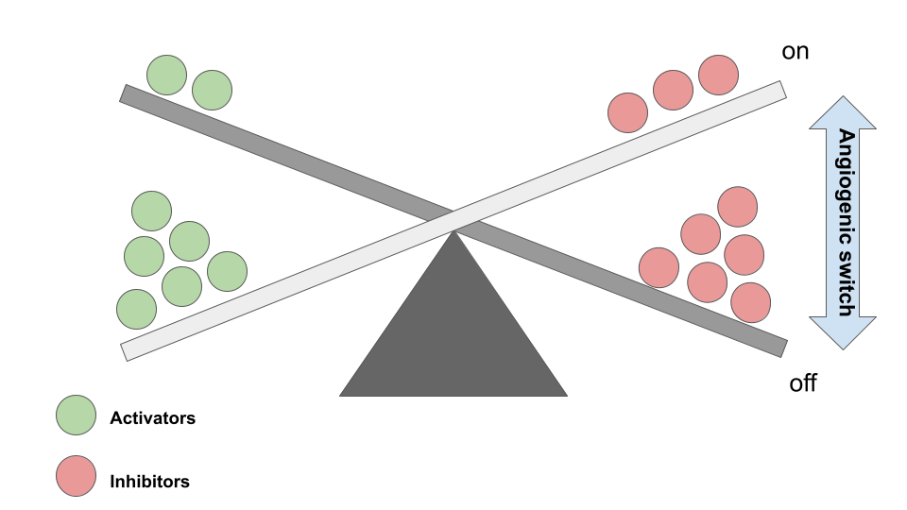
Genomic Instability and Angiogenic Switch
Activators | Inhibitors
Over-expression of pro-angiogenic factors | Down regulation of anti-angiogenic factors
VEGF-A, VEGF-B, VEGF-C, FGF1 (aFGF), FGF (bFGF), other FGFs, etc | Thrombospondin-1, -2, interferon alpha/beta, angiostatin, endostatin, collagen IV fragments, etc

The "angiogenic switch" is a time-restricted event during tumor progression where the balance between pro- and anti-angiogenic factors tilts towards a pro-angiogenic outcome. The result is a transition from dormant avascularized hyperplasia to an outgrowth of a vascularized tumor and eventually to malignant tumor progression. The molecular mechanism underlying the angiogenic switch has been intensely studied. A large number of pro-angiogenic factors and angiogenic inhibitors activated and repressed in their activities during the angiogenic switch have been identified and characterized.²

Inflammation and Cancer
The symptoms of inflammation are heat (calor), pain (dolor), redness (rubor), and swelling (tumor). Many cancers arise from sites of chronic infection, irritation, and inflammation. The tumor microenvironment contains these inflammatory cells and has a large role in tumorigenesis - causing proliferation, survival and migration of cancerous cells.¹⁰
A link between chronic inflammation and cancer has been suspected for a long time on the basis of epidemiological data such as the observation that chronic inflammation often increases cancer risk in inflamed tissues and long-term use of nonsteroidal anti-inflammatory drugs reduces the risk of several cancers.¹⁰
Additionally, a variety of cell types are involved in inflammation such as macrophages and lymphocytes as well as cytokines that these cells produce. Deletion of certain inflammatory mediators, as seen in mouse studies, reduces cancer susceptibility in these animals. Key mediators for the link between inflammation and cancer are NF-kB and TNF-a. In mouse models, treatment with an anti-TNF-a antibody, or suppression of NF-kB by induction of the IkB suppressor of NF-kB, blocked progression to carcinoma. Suppression of NF-kB function in young mice did not affect carcinoma development - meaning that the promotion–progression phases of malignant transformation are the ones enhanced by inflammation, not the initiation phase. In some human and mouse cancers, the malignant cells themselves, in addition to the inflammatory cell types, can produce the offending cytokines.¹⁰

Malignancy
Carcinogenesis will lead to the formation of malignant tumors that invade and destroy adjacent normal tissue; benign tumors grow by expansion, are usually encapsulated, and do not invade surrounding tissue. Benign tumors may push aside normal tissue and may become life threatening if they press on nerves or blood vessels or if they secrete biologically active substances, such as hormones, that alter normal homeostatic mechanisms.¹⁰
Benign tumors remain localized and do not metastasize and will usually resemble normal tissue more closely than malignant tumors. Malignant tumors metastasis through lymphatic channels or blood vessels to lymph nodes and other tissues in the body. Malignant tumor cells are less well differentiated (anaplastic) than normal cells of the tissue in which they arise. In some cases, malignant neoplastic cells will structurally and functionally resemble the normal tissue in which they arise. As the malignant neoplasm progresses it will invade the surrounding tissues, and metastasize. The malignant cells will have less resemblance to the normal cell of origin. The development of less well-differentiated normal cells in a population of differentiated normal cells is sometimes called dedifferentiation.¹⁰

Summary of Benign and Malignant Neoplasms
Feature | Benign | Malignant
General effect on the host | Little; usually does not cause death | Will almost always kill the host if untreated
Rate of growth | Slow; may stop or regress | More rapid (but slower than “repair tissue”) Autonomous; never stops or regresses
Histologic features | Encapsulated; remains localized at primary site | Infiltrates or invades; metastasizes
Mode of growth | Usually grows by expansion, displacing surrounding normal tissue | Invades, destroys and replaces surrounding normal tissue
Metastasis | Does not metastasize | Most can metastasize
Architecture | Encapsulated;has complex stroma and adequate blood supply | Not encapsulated; usually has poorly developed stroma; may become necrotic at center
Danger to host | Most are without lethal significance | Always ultimately lethal unless removed
Injury to host | Usually negligible but may become very large and compress or obstruct vital tissue | Can kill host directly by destruction of vital tissue
Radiation sensitivity | Radiation sensitivity near that of normal parent cell; rarely treated with radiation | Radiation sensitivity increased in rough proportion to malignancy; often treated with radiation
Behavior in tissue | Cells are cohesive and inhibited by mutual contact | Cells do not cohere; frequently not inhibited by mutual contact
Resemblance in tissue | Cells and architecture resemble tissue of origin | Cells atypical and pleomorphic; disorganized bizarre architecture
Mitotic figures | Mitotic figures are rare and normal | Mitotic figures may be numerous and abnormal in polarity and configuration
Shape of nucleus | Normal and regular; show usual stain affinity | Irregular; nucleus frequently hyperchromatic
Size of nucleus | Normal; ratio of nucleus to cytoplasm near normal | Frequently large; nucleus-to-cytoplasm ratio increased
Nucleolus | Not conspicuous | Hyperchromatic and larger than normal
From Handbook of Toxicologic Pathology, 2nd Ed. W. M Haschek, C. G. Rousseaux and M. A. Wallig, eds. (2002) Academic Press, Vol. I, Table III, p. 89.

Conclusion
While the genetic basis of tumorigenesis may vary between cancer types, the steps, both cellular and molecular, required for metastasis are basically the same. In normal tissue, homeostasis is maintained between epithelial cells and their microenvironment, such as vascular endothelial cells, fibroblasts, immune cells, and the extracellular matrix. In the cancerous state, these interactions become deregulated.
As a tumor begins, nutrients are provided by direct diffusion from the circulation. Local tissue invasion can result in pressure on normal tissues, which can lead to inflammation, or the tumor may produce substances (e.g. collagenase, gelatinase, stromelysin) that lead to enzymatic destruction of tissues. As a result, the synthesis of tumor angiogenesis factors cause formation of an independent vascular supply to the tumor.
The pivotal role of cell proliferation in all phases (e.g., initiation, promotion, progression) of the multistep process of tumorigenesis is completely linked to positive and negative cell cycle control mechanisms as influenced by oncogenes, tumor suppressor genes, growth factors and their cognate receptors, hormones and their receptors, and the action of exogenous agents (e.g., chemicals and viruses) on cell cycle control. Uncontrolled cellular proliferation is the hallmark of neoplasia, and many cancer cells demonstrate damage to genes that regulate their cell cycles directly.

- The four main points of emphasis in this lecture are,
  - understanding why cancer is a genetic disease,
  - the differences between initiation, promotion, and progression in milti-step tumorigenesis,
  - how the tumor microenvironment impacts tumor growth, and
  - how inflammation relates to cancer

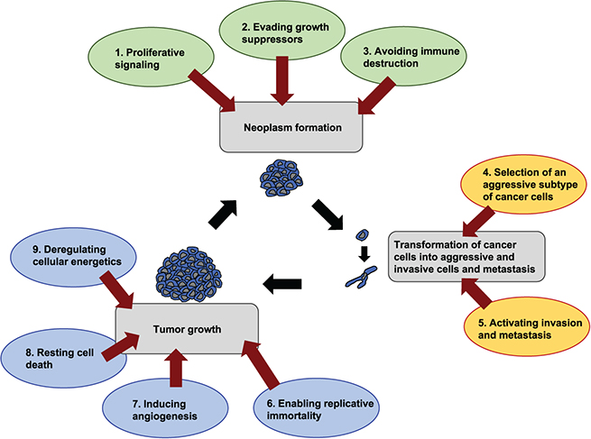
From Physics of Cancer by Claudia Tanja Mierke

References
- Alberts, Bruce, Alexander Johnson, Julian Lewis, Martin Raff, Keith Roberts, and Peter Walter. Molecular Biology of the Cell. New York: Garland Science, 2002. Print.
- Baeriswyl, Vanessa, and Gerhard Christofori. “The angiogenic switch in carcinogenesis.” Seminars in cancer biology vol. 19,5 (2009): 329-37. doi:10.1016/j.semcancer.2009.05.003
- Gerdes, Michael J et al. “Emerging understanding of multiscale tumor heterogeneity.” Frontiers in oncology vol. 4 366. 18 Dec. 2014, doi:10.3389/fonc.2014.00366
- Grønbaek, Kirsten et al. “Epigenetic changes in cancer.” APMIS : acta pathologica, microbiologica, et immunologica Scandinavica vol. 115,10 (2007): 1039-59. doi:10.1111/j.1600-0463.2007.apm_636.xml.x
- Hanahan, Douglas, and Robert A Weinberg. “Hallmarks of cancer: the next generation.” Cell vol. 144,5 (2011): 646-74. doi:10.1016/j.cell.2011.02.013
- Lodish, Harvey F. Molecular Cell Biology. 4th ed. New York: W.H. Freeman, 2000.
- Luch, Andreas. “Nature and nurture - lessons from chemical carcinogenesis.” Nature reviews. Cancer vol. 5,2 (2005): 113-25. doi:10.1038/nrc1546
- Malarkey, DE; Hoenerhoff, M; Maronpot, RR. Carcinogenesis: Mechanisms and Manifestations. Waltham, MA, Haschek and Rousseaux’s Handbook of Toxicologic Pathology Vol 1 (2013) :107-146. doi: 10.1016/B978-0-12-415759-0.00005-4
- Mierke, Claudia Tanja. Physics of Cancer. IOP Publishing Ltd, 2015.
- Ruddon, Raymond W. Cancer Biology. New York: Oxford University Press, 1995.
- Siddiqui, Imtiaz A et al. “Resveratrol nanoformulation for cancer prevention and therapy.” Annals of the New York Academy of Sciences vol. 1348,1 (2015): 20-31. doi:10.1111/nyas.12811
- Scott, R E et al. “Mechanisms for the initiation and promotion of carcinogenesis: a review and a new concept.” Mayo Clinic proceedings vol. 59,2 (1984): 107-17. doi:10.1016/s0025-6196(12)60244-4
- Weinberg, Robert A. The Biology of Cancer. , 2014. Print.
- Zhu X; Wetta H. Genetics and Epigenetics in Tumorigenesis: Separately or Linked?. Austin Publishing Group (2014)

